**How to Create or Delete an Amazon EBS Volume**

The Amazon Elastic Block Store (Amazon EBS) offers persistent storage for Amazon EC2 instances. Amazon EBS volumes provide a scalable storage service, which persists independently of the instance life. An EBS volume is cheaper and scalable.

1. Go to the AWS console through the URL [http://aws.amazon.com/console.](http://aws.amazon.com/console) Select the EC2 service. From the EC2 dashboard, select EBS Volumes or Volumes.

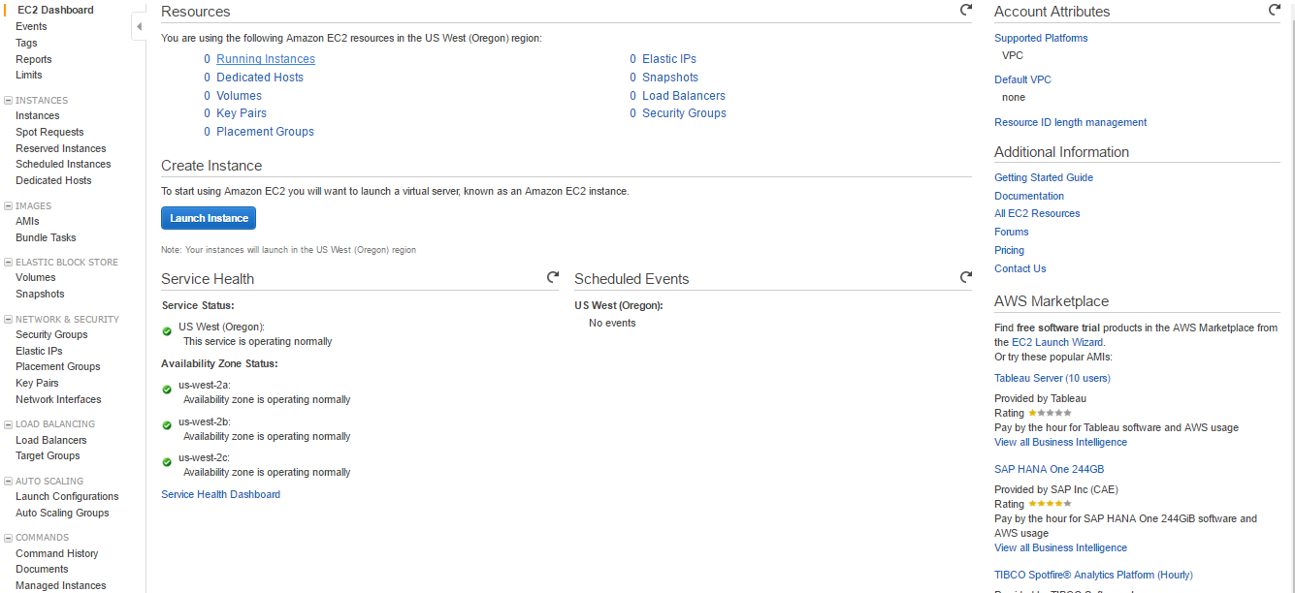

1. The EBS Volumes dashboard lists all the volumes available in that region. Click on “Create Volume”.

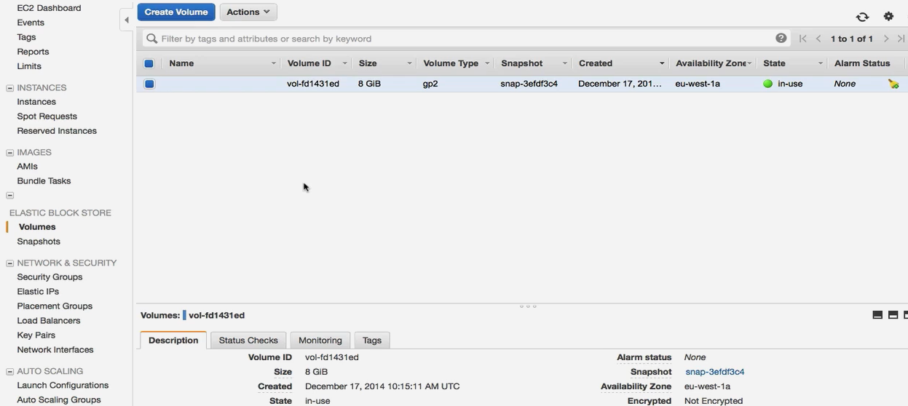

1. In the Create Volume dialog, select the volume types. AWS provides few types of volumes. A General Purpose (SSD) volume generally provides about 3 IOPS per GB. However, in comparison to Provisioned IOPS, which provides for a performance of up to 2000 IOPS or we can specify how many you need. There is one more volume type i.e Magnetic, it is cheaper for flat file storage

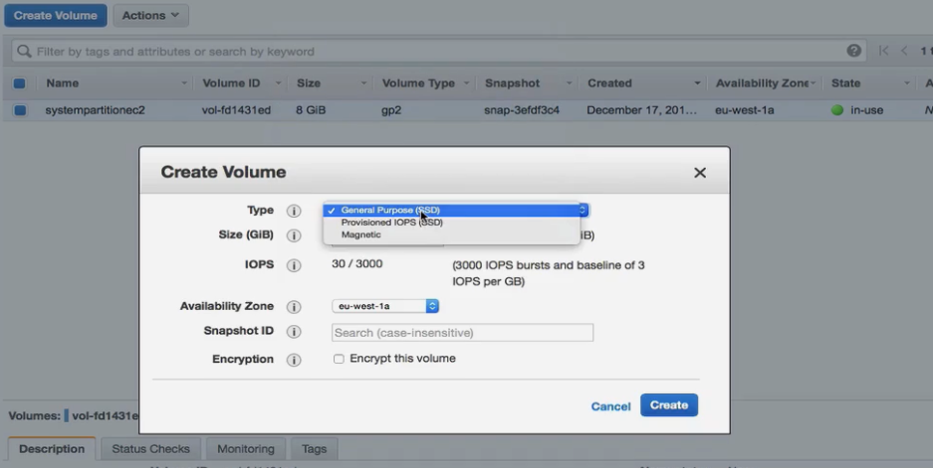

1. For the Magnetic volume, provide the value for the volume size and select the availability zone and snapshot. The availability zone is very important as a volume can be attached to only an instance in the same availability zone. Click on “Create”.

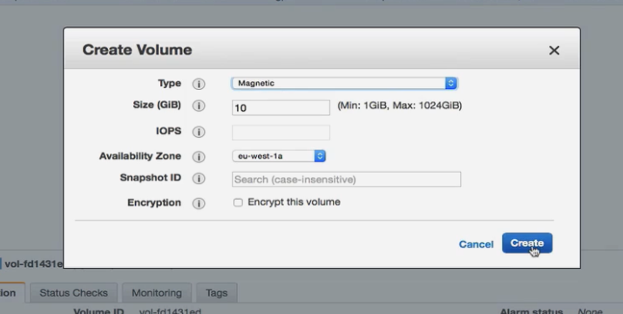

1. The volume will be created and available in the EBS dashboard. Since it has not been assigned to any instance it will be in the “available” state.



1. Select “Provisioned IOPS” in step#3, if the user wants to create a provisioned IOPS volume. Provide the value for IOPS, the size (GB) and select the availability zone. Click on “Create”

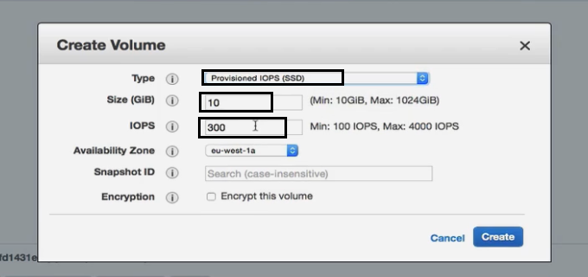

1. The resultant volume type will be io1. It will display the IOPS in brackets where volume type
2. To delete a volume, select the volume and right click. Select “Delete Volume” or go to action menu then select Delete Volume

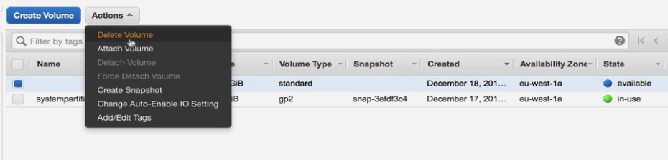

1. AWS will confirm before deleting the volume. Click on “Yes, Delete”.

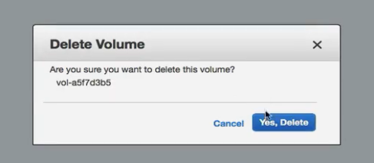

1. The volume has been deleted, now it looks like as below.

